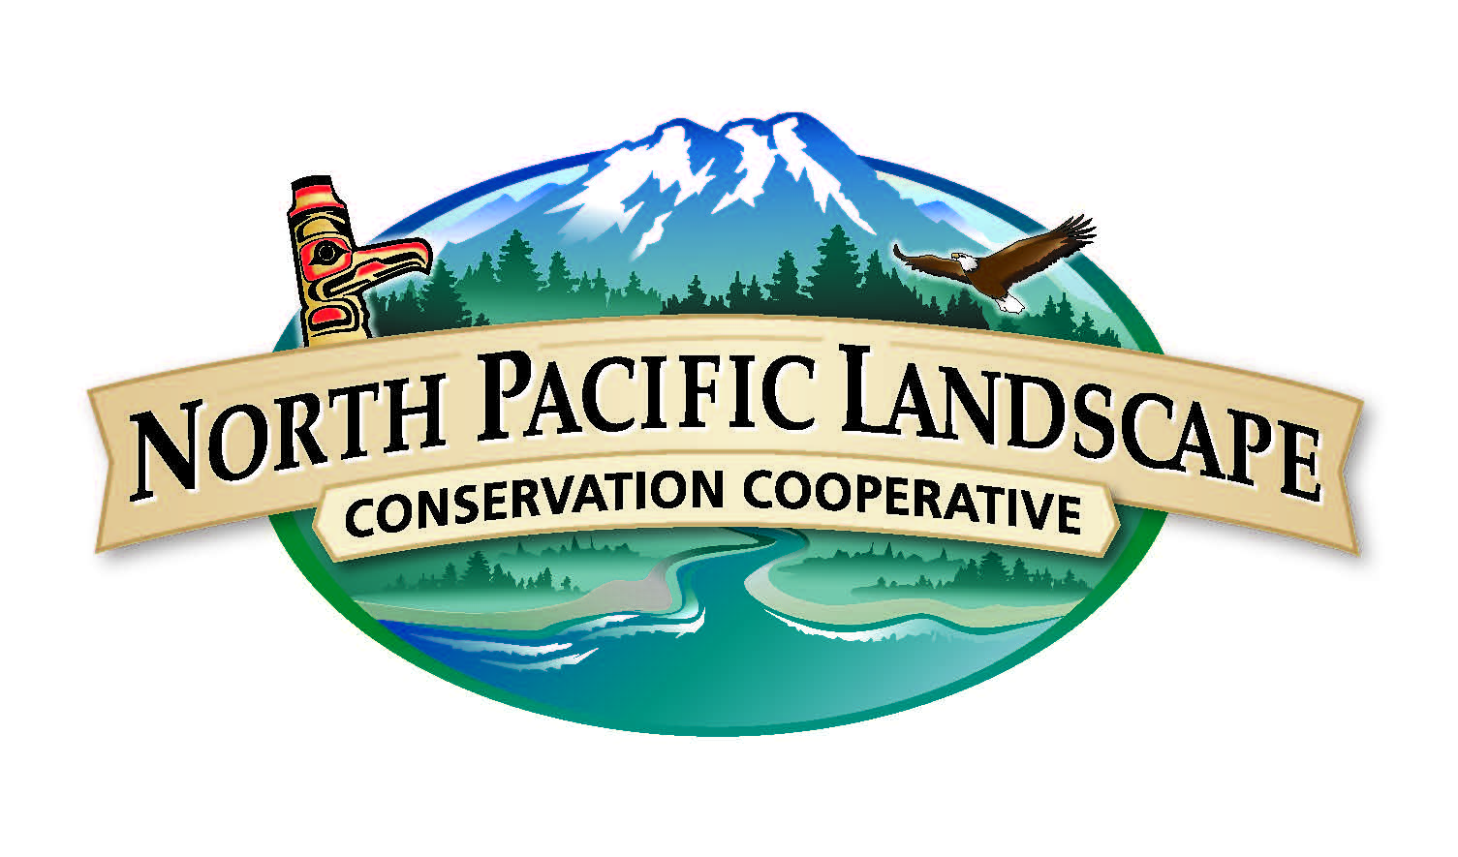
North Pacific

Landscape Conservation Cooperative
S-TEK Subcommittee Meeting Summary
January 26, 2016

Attendees: John Alexander (Klamath Bird Observatory), Mike Cox (EPA), Nicole DeCrappeo (NW CSC), Mike Goldstein (USFS), Judy Gordon (USFWS), Roger Harding (ADFG), Jennie Hoffman (Adaptation Insight) Peter Kiffney (NOAA), Frank Lake (USFS), Chris Lauver (NPS), Kathy Lynn (Univ. OR), Eric Mielbrecht (EcoAdapt), Louise de Montigny (B.C. FLNRO), Steve Morey (USFWS), Darrin Sharp (CIRC, OSU), Chris Tunnoch (B.C. FLNRO), Thomas White (BC Climate Action Secretariat), Andrea Woodward (USGS), Meghan Kearney (NPLCC), Mary Mahaffy (NPLCC)

National Academy of Science Review:
Review released Dec. 4. Overall positive review – acknowledged that the Nation needs to take a landscape approach to conservation and addressing this need with LCCs is justified. Unique – no other program designed to address landscape conservation needs at a national scale for all natural and cultural resources; provides a way to bridge research and management efforts. Improved coordination needed for Joint Ventures and LCCs. LCCs and CSCs need to explicitly state how their research efforts differ and how they complement each other. Need to identify and build on existing examples of coordination across the Network. LCCs need to improve their evaluation process, including better capturing contributions made by all partner agencies or groups toward common objectives. Establishment of metrics should be a high priority. Note: This is something S-TEK should consider during planning.

Notification of Funding Opportunity (NOFO):
The request for pre-proposals and details is posted on the NPLCC website (link). Pre-proposals are due March 18th and invited detailed proposals will be due May 18th. The only action included in the NOFO is the following action that was included in the 2015-2016 S-TEK Strategy Implementation Plan: “Develop/improve information on how climate change and associated adaptation actions will affect linkages between ecological and human resources (including tribal and First Nations subsistence activities and cultural resources).” The criteria include a statement that priority will be given to Tribal and First Nations entities over non-Tribal entities for projects addressing Tribal and First Nations subsistence and cultural resources. The NOFO is open for all applicants with no restrictions identified (as required by the funding authorization).
S-TEK Action: Reviewers for pre-proposals are needed – please email Mary Mahaffy if you are interested and available to assist. Pre-proposals are no longer than 3 pages. Review period will be for at least 2 weeks starting March 21.
Steering Committee Updates:
The Steering Committee met in Juneau Dec. 3-5. A joint meeting was held with the NW Boreal LCC the first day. The Steering Committee developed revised a NPLCC mission and goals. The new mission is broader and there are fewer (4 versus 7) goals. See below in the section of the development of the 2017-2021 S-TK Strategy for the new draft mission and goals (they have not been adopted yet).
The Steering Committee had an exercise where they identified partner needs and potential areas of focus for the NPLCC. Ideas were grouped and voted on to see what four topics they would discuss. They were the following:
- Increase profile of the NPLCC in BC - BC and Canada are paying more attention to LCCs now so the NPLCC is in a good position to gain momentum. There is a desire to incorporate more Canadian agencies into this partnership. Barry Smith (CWS and NPLCC co-chair) plans to do more outreach with other federal agencies. Having a fall in-person NPLCC meeting will be a good opportunity for engaging others.
- Tribal Participation – Tribal participants noted that structural issues still are important to address. The noted that convening parties and getting them to agree on their goals can be difficult. They said that the NPLCC’s broad approach is strength. However, the voluntary aspect can make it difficult to meet goals and interferes with LCC’s ability to capitalize on their strength.
- Yellow cedar – A range-wide analysis of yellow cedar was recommended with a multi-dimensional look. The group thought that a good activity for the NPLCC would be to convene a diverse group across NPLCC to discuss yellow cedar decline. They recommended working with the Alaska Coastal Rainforest Center on creating a forum session for yellow cedar and possibly other cedar species as well.
- Fire – A recommendation was made to potentially have a focus on wildland [prescribed and wild] fire for S-TEK ecological consideration. Incorporation of social science is important. Changing fire regimes influenced by climate and resultant landscape patterns mean that traditional burning practices (when reinstated, if not currently) are impacted. Question about what NPLCC could do in terms of connecting NPLCC products with public and understand where the general public stands on these issues. It was discussed during the S-TEK meeting that the changes in fire regimes and the effects of fire have an impact on Tribal culture and cultural ecosystem services. It is critical to include Tribes and tribal community based burning groups (e.g., Indigenous Cultural Burning Networks) as fire management and planning partners. This would facilitate tribal government and community organizations participation in to DOI-BIA wildland fire (Reserved Treaty Rights Lands Program) and Climate Change initiatives.

In addition to the above activities/topics, the need to strengthen working with the National Fish Habitat Partnerships (NFHP) across the NPLCC was noted. A NFHP meeting was being held nearby and several people from the NFHP meeting joined the NPLCC meeting.

The Steering Committee approved operating under the 2015-2016 S-TEK Strategy Implementation Plan as requested by S-TEK. They approved the NOFO and continuation of other activities proposed in the Implementation Plan. The Steering Committee also approved the metrics developed by S-TEK as proposed.

S-TEK discussed that the metrics originally developed (and just adopted) were intended to be a starting place for metrics, with a primary focus on the targeting of projects, projects meeting their deliverable requirements, and overall use of products. It was acknowledged that more work was needed for more ecologically based/ environmental measures. It was noted that part of the reason we went with the more general metrics and not the ecologically based measures is that the primary role of the NPLCC is to provide information and tools for managers and other decision-makers to use in their on-the-ground projects. Note: This is something S-TEK should consider when planning the 2017-2021 S-TK Strategy.
Additional S-TEK Updates:
- The first core team meeting for the Lower Columbia and Washington/Oregon Coast Landscape Conservation Design was held in Portland on January 20th. We are primarily in the first phase of the project (convening partners, building the Core Team and identifying the technical advisory, and identifying common interests and goals). This effort is collaborative, partner-driven, non-regulatory, and builds from existing planning and science. The focus is on needs for collaborative conservation. There will be a synthesis of landscape science and planning efforts, assessment of landscape scale stressors, including climate change, and a structure build for shared data and information, spatial prioritization and shared strategies. Using extra end of year funding from USFWS Regional Office, we are starting the second phase (assessment) with help from the Pacific Birds Habitat Joint Venture. Project information can be found at https://sites.google.com/site/lowercolumbiariverlcd/home,

S-TEK Action: Visit the site and join as a Core Team member or Technical Advisor if you have interest in participating.

- Southeast Alaska Workshop planning is well under way; Climate Change in Southeast Alaska – Informing Sustainable Management of Water Resources and Anadromous Fisheries. The workshop will be April 12 -15 in Juneau. The Workshop Purpose is to bring scientists together with resource management practitioners to enrich knowledge, foster collaboration, and inform sustainable management of priority aquatic resources. Leads for the project are Julianne Thompson (USFS) and Debbie Hart (SE Alaska Fish Habitat Partnership). Anticipated Outcomes for the workshop include the following:
- Share progress and findings of relevant studies
- Distribute analytical tools that could be used for resource management
- Identify knowledge gaps and identify strategic actions
- Integrate traditional knowledge into studies and assessments
- Identify long-term data platforms for aquatic resources
- Endorse a regional watershed classification to discern hydrologic regime shifts
- Develop tools to predict changing ice and snow conditions and implications for hydrologic regimes
- Develop tools to predict response of salmon habitat to changing hydrologic regimes in SE Alaska
S-TEK Action: Contact Mike Goldstein (on planning committee) or the project leads if you have questions.
- The online Tribal Climate Change Guide is up and running and has new tabs added - climate adaptation plans, climate education, and climate jobs.

S-TEK Action: Kathy Lynn asked S-TEK (and others) to visit the guide and send suggestions to her for information to add or other suggestions.
- WildLinks 2015 hosted by the Cascadia Partner Forum, Conservation Northwest, Skagit Environmental Endowment Commission, the NPLCC and the GNLCC, was very successful this year. There was a heightened level of energy this year compared with past years with a lot of enthusiasm for the work and engaged conversations about it. Great info gathering, participations from Tribe/First Nations. Landscape connectivity, fire regimes, and eDNA were key discussions this year. The NPLCC has been contacted by Conservation Northwest about potentially expanding current work funded by the GNLCC related to eDNA in B.C. working with a First Nations that has expressed work in being involved in the effort.
2017-2021 S-TK Strategy Development:
A focus of the next few S-TEK meetings needs to be development of a new Strategy since this is the last year for our current Strategy. We can continue with any topics/activities in our current Strategy, add different topics/activities, or refine the ones we have. The current S-TEK Strategy includes four Guiding Principles and 5 Priority Topics that we may want to change. We may want to consider the National Academy of Science findings as we develop a new Strategy. Additionally, the Steering Committee has drafted a revised mission and fewer goals for the NPLCC 5-Year Strategic Plan, 2016-2012 that may change some of the focuses we propose for the next five years. The draft new mission and goals are as follows:
Draft New Mission: In the face of a changing climate and other landscape-scale stressors, the North Pacific Landscape Conservation Cooperative supports development and application of useful science; we coordinate and disseminate that science; and we serve as a convener to further collaborative efforts to inform and advance landscape-scale conservation and sustainable resource management.
Draft New Goals:
- Maximize the ability of natural and cultural resource managers to make informed landscape-level conservation/sustainable resource management decisions by understanding their conservation challenges and providing practical and useable information and solutions (Informing Management Decisions)
- Identify trans-boundary landscape-level natural and cultural resource opportunities for (and barriers to) landscape-level conservation/sustainable resource management that the LCC is uniquely qualified to address. (Unique role of LCC)
- Promote identification, open-access, use, and sharing of science, traditional knowledge and other relevant information to determine priorities for applied science. (Use/Access of information)
- Promote awareness and understanding of the work of the NPLCC (partnerships and products); and the effects of climate change on ecosystems, resources, cultures, and economies. (Outreach)

As we develop the new Strategy, we need to incorporate a social science component that will provide a broader picture as described by the following diagram presented by the NW Boreal LCC at the joint Steering Committee meeting:
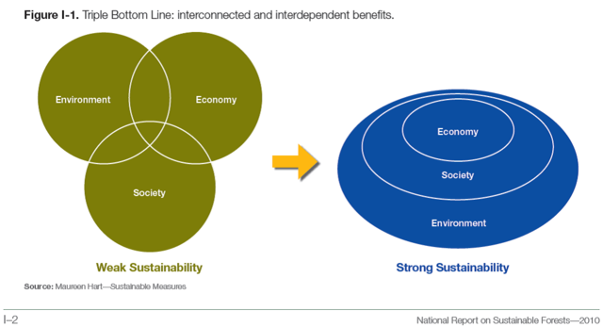
NPLCC Communications:
Meghan Kearney gave a brief update on NPLCC communication activities. We will soon release the NPLCC annual report for 2015, the LCC Network annual report is also being developed now. The 2nd Annual Northwest Climate Magazine is being developed. We are continuing to grow interest in our mailings (Climate Science Digest & NPLCC Tidings), consistently increased numbers in subscribers/readers. We are also building a collaborative website for the Lower Columbia LCD Project. Any partners with anything they would like to see highlighted in our newsletter or via our web networks please send them to Meghan.
Round Robin:
- Eric Mielbrecht – EcoAdapt is expanding its climate vulnerability and adaptation planning work with the US Forest Service and BLM to Northern California (Six Rivers, Klamath, Shasta-Trinity & Mendocino National Forests and regional BLM lands). They are hoping to bring in relevant stakeholders, organizations and agencies beyond the Forest Service and BLM, and collaborate with emerging and past research efforts in the area. A brief overview of the project is available here. Anyone wanting to be involved should contact Eric.
- John Alexander – Opportunities exist for cross LCC Klamath Basin activities and this may be a good place for involvement by the NPLCC. John and Mary agreed to follow up on ideas here.
- Judy Gordon – Abernathy Fish Health Center is continuing their vulnerability assessment work at the National Fish Hatcheries (NFH). Quilcene NFH is completed. Work is still underway at Makah NFH and Quinault NFH. Judy will be stepping down from S-TEK because she has accepted a new position in USFWS as the Fisheries Program Deputy Assistant Regional Director. Congratulations to Judy and a big thank you for her participation in the subcommittee. We will miss having her on S-TEK.
- Chris Tunnoch – Madeline Maley (BC FLNRO) has transferred to a new position in the Wildfire Branch so will be stepping down from her involvement with LCCs (GNLCC Steering Committee, involvement with NPLCC, and National LCC Council). Diane Nichols (NPLCC Steering Committee Member) will be taking Madeline’s role on the National LCC Council.
- Mike Cox – Mike is working with the Puget Sound Partnership on updates to the Action Agenda. A request for proposals to serve as lead for projects related to stormwater, shellfish, and habitat has been released. Issues related to climate change are being incorporated into each action type.
- Roger Harding – Roger was sitting in for Sue Rodman at this meeting and ADFG is trying to work out details on how to increase Fish Habitat Partnership and LCC cooperation and coordination. An all Alaska FHP face-to-face meeting will be held in Anchorage on Feb. 9th from 1:15 – 5:00 PM Alaska Time. A final agenda will be out soon.
- Frank Lake - A new publication (General Tech. Report) from the USDA Forest Service and National Agroforestry Center on Agroforestry and climate change assessment is forthcoming this next year. Another Gen. Tech. Report focuses on Non-timber forests, cultural/social/economic aspects and climate change. Frank is a contributing author of the chapters in these reports. See email for attachments.
- Steve Morey – Steve has appreciated the involvement by USFWS Fisheries and Refuge Programs in the NPLCC. He also sees opportunities for expansion of NPLCC work to better support efforts by USFWS Ecological Services Program because of their efforts related to species listing, recovery and regulatory activities. He saw value with including action items that better integrate landscape-level assessments into existing science so it can be used. Addressing species status and climate change impacts would be helpful and he thought that maybe NPLCC could facilitate this.
- Peter Kiffney (shared post meeting) – A number of NOAA scientists participated in the PAWs II workshop (Pacific anomalies workshop. Sponsored by Nanoos. You can find all the info, agenda, live stream, etc for the workshop on their website nanoos.org.)and several agreed to write papers. The agency as a whole released the NOAA Fisheries Climate Science Strategy, and on the West Coast efforts are underway to generate the West Coast Climate Science Strategy. It will probably be ready for external review in summertime, and NPLCC is one group they have identified as an audience/partner. There is a lot of activity occurring related to the West Coast Harmful Algal Bloom. NOAA scientists are collecting data on the dynamics of this bloom and this it is a preview of things to come under warmer ocean conditions.

Meeting Schedules:
Steering Committee: All dates still need to be scheduled
- April: Call/ WebEx Meeting
- June: In-person Portland area, possibly with the GNLCC
- Fall (Oct/Nov): In-person B.C., likely Vancouver

S-TEK: Please hold the following dates/times and complete the doodle poll
- March 16, 10:00 – 11:30 Pacific Time/ 9:00 – 10:30 Alaska Time: Call/WebEx
- April – In-person meeting and regional hubs if needed – Doodle Poll in email
- May 19, 10:00 – 11:00 Pacific Time/ 9:00 – 10:00 Alaska if needed as follow-up to April meeting; Call/WebEx

