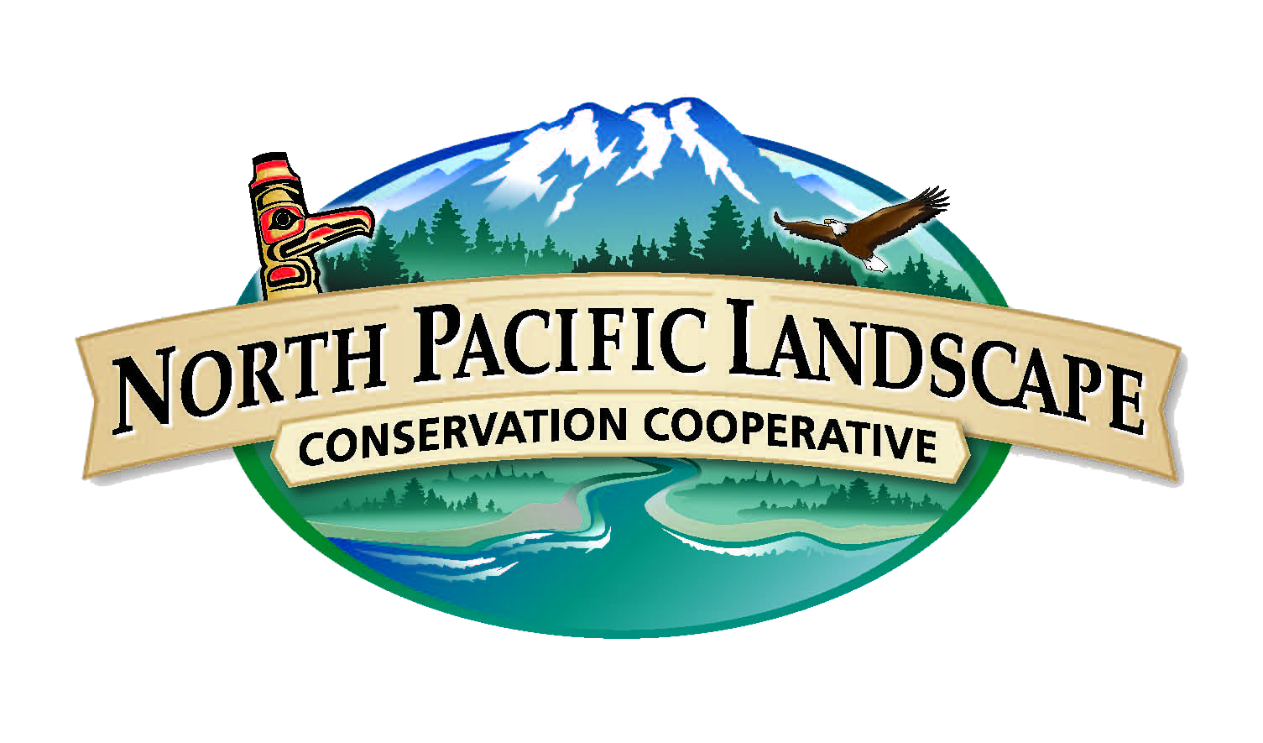

North Pacific Landscape Conservation Cooperative

DRAFT 5 - Year Strategic Plan (2016-2021)

North Pacific Landscape Conservation Cooperative

5 - Year Strategic Plan (2016 – 2021)

Draft
November 20, 2015

John Mankowski
Coordinator, North Pacific Landscape Conservation Cooperative
510 Desmond Dr. SE, Suite 102 Lacey, WA 98503
(360) 534-9330; john_mankowski@fws.gov

http://www.nplcc.org

NPLCC VISION, MISSION & GOALS

{NEW} Vision

Natural and cultural resources successfully respond to rapidly changing landscapes and seascapes.

In our vision, we see:
    - Natural and cultural resources are managed within a truly landscape/seascape scale context.
    - Landscape-scale managers incorporate multiple social, economic, environmental and cultural factors in their management.
    - Landscape-scale conservation and sustainable resource management knows no jurisdictional boundaries.
    - Responding to a rapidly changing landscape, including considering climate change in management practice, is normal and commonplace.
    - It is easy to find, acquire and use quality climate and landscape-scale science and information.
In our vision, we believe:
- We are all struggling to keep up with the rapid changes in land- and seascapes brought on by climate change and other large-scale stressors.
- Bringing more voices and perspectives authentically to the table is essential to fully respond to these changes.
- When we work collaboratively together, we can better provide information to and give voice to those who are working to sustain ecological integrity and health.
- We are here to support the decision makers and managers that make and implement decisions about landscape-level conservation and sustainable resource management.
- With a relentless commitment to collaboration, we can make sustainable connections across landscapes.

{REVISED} Mission Statement

In the face of a changing climate and other landscape-scale stressors, the North Pacific Landscape Conservation Cooperative supports development and application of useful science; we coordinate and disseminate that science; and we serve as a convener to further collaborative efforts to inform and advance landscape-scale conservation and sustainable resource management.
{PREVIOUS} The North Pacific Landscape Conservation Cooperative promotes development, coordination and dissemination of science to inform landscape level conservation and sustainable resource management in the face of a changing climate and related stressors.

{REVISED} NPLCC Goals

- Maximize the ability of natural and cultural resource managers to make informed landscape-level conservation/sustainable resource management decisions by understanding their conservation challenges and providing practical and useable information and solutions (Informing Management Decisions)

- Identify trans-boundary landscape-level natural and cultural resource opportunities for (and barriers to) landscape-level conservation/sustainable resource management that the LCC is uniquely qualified to address. (Unique role of LCC)

- Promote identification, open-access, use, and sharing of science, traditional knowledge and other relevant information to determine priorities for applied science.. (Use/Access of information)

- Promote awareness and understanding of the work of the NPLCC (partnerships and products); and the effects of climate change on ecosystems, resources, cultures, and economies. (Outreach)

{PREVIOUS}
- Maximize the ability of partners to make informed decisions with respect to conservation and sustainable resource management of priority natural and cultural resources subject to climate change and related large-scale stressors in the NPLCC region. (Conservation and restoration)

- Identify and address trans-boundary landscape-level natural and cultural resource information needs that the LCC is uniquely qualified to address -- including the identification of opportunities for (and barriers to) landscape-level conservation/sustainable resource management. (Unique role of LCC)

- Identify priorities for applied science and other information for conservation/sustainable resource management. Coordinate efforts with the relevant Climate Science Centers and other research entities to help inform research priorities. (Information priorities)

- Promote identification, use, and sharing of science, traditional knowledge and other relevant information to support conservation/sustainable resource management, and adaptive management decisions. (Use of information)

- Maximize the availability and accessibility of data and information about large-scale stressors and their impacts on natural and cultural resources, and about conservation/sustainable resource management approaches and effectiveness. (Availability of information)

- Promote coordination and efficiency of efforts among resource managers and science entities that are addressing science, traditional knowledge and other relevant information to achieve landscape level conservation/sustainable resource management. (Coordination)

- Promote awareness and understanding of NPLCC and its products for landscape-level conservation and the effects of climate change on ecosystems, resources, cultures, and economies. (Outreach)

Next Steps -- Once the revised Vision, Mission and Goals are approved, SMART objectives will be added under each goal. Annual work plans will be developed to specify which actions (with performance metrics) the NPLCC will support to achieve each goal.

