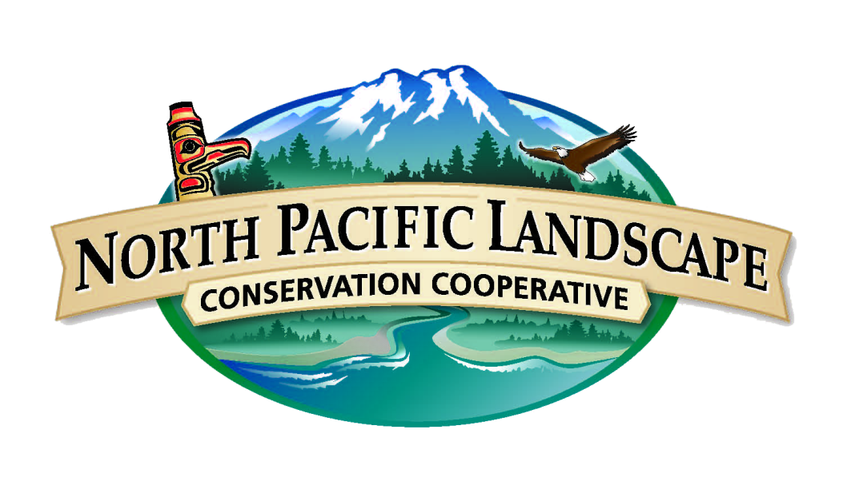
Implementation Plan
for the
NPLCC Communication and Outreach Strategy, 2016

November 2015
Introduction
The 2016 Communication and Outreach Implementation Plan identifies the NPLCC top communication and outreach priority activities for 2016. This plan was developed by the Communication and Outreach (COR) Subcommittee and grounded by the COR 5-year Strategy, which was approved by the NPLCC Steering Committee in 2013. The priority activities for 2016 remain aligned with the objectives and target audiences addressed in the COR strategy and seek to focus on implementation of tools and developing/tracking communication performance measures. The major goal of the implementation plan is to aid the NPLCC in continued achievement of communication goals, development of communications products, and outreach to the NPLCC’s target audiences.
The following 2016 priorities were first identified by the COR subcommittee and will be presented to the NPLCC Steering Committee. Priorities were largely carried over from successes in 2014 and 2015, with a few adjustments and additions. They will be carried out through 2016, with continued attention to successes and challenges via audience feedback and performance measures.
Implementation Plan
The below table identifies our key priorities, tools and implementation strategies the NPLCC will focus on in 2016. An overarching focus for the 2016 Implementation Plan, embedded throughout each priority action, is further emphasis on evaluating and showcasing the value of the NPLCC and LCC Network. Additionally, in 2016, the LCC Network will have a Communication Strategy and we will seek to align our priority actions, tools, and target goals with the Network and other LCCs. These priorities will be headed by the NPLCC Communication Specialist with the assistance of NPLCC staff, COR subcommittee, key subcommittee members, and representatives from EnviroIssues. The COR subcommittee convenes quarterly and will continue to review and discuss progress of the implementation plan throughout 2015.
Priority Actions, Tools & Tasks
PRIORITY ACTIONS | TOOLS/TASKS
1. NPLCC Website/Social Media Content | - More frequent direct links to website in outreach materials  - Increase engagement on social media
2. E-newsletters | - Quarterly Tidings  - Evaluate readership with NW Climate Science Center  - Continue increase in subscribers and readership
3. Science-Management Webinars | - Continue webinars  - Increase YouTube engagement with ongoing promotion
4. Collaboration with regional Climate-Science entities (CSCs, RISA, Hubs, etc.) | - Seek out more opportunities for collaboration in showcasing value of NPLCC (i.e. working with partners to show how NPLCC has benefited their work)
5. NPLCC-funded & supported Project Communication | - Review past project for successes/challenges and revisit where needed  - Develop more project-related narratives, beyond just “posting”  - Evaluate where our work is being/has been used and develop outreach
6. Increase communication of climate change impacts to cultural resources (tribal and non-tribal) | - Incorporate COR into Recommendations from T/FN Committee  - Increased communication with T/FNs and offer communication and outreach support
7. Highlight variety of  work and diversity  of partners | - Provide COR support to partners – assistance with information sharing and delivery to our networks
8. Develop and strengthen target goals and performance measures for NPLCC 2015 Priority Actions | - Continue successful 2015 targets w/ adjustments where needed  - Develop more qualitative measures, i.e. interviews with PIs, end-users of NPLCC products.

2016 COR Draft Performance Measures
PRIORITY ACTION | FREQUENCY | TARGET INCREASE | MEASURES
1 | Bi-weekly news, calendar updates  Daily posts on Facebook/Twitter | 10% increase in annual website visits;  Double Facebook & Twitter followers;  5% increase in engagement | Google Analytics,  Facebook Analytics,  Twitter Analytics
2 | Monthly Digest; Quarterly Tidings | 20% increase in subscribers, particularly in AK and Canada;  15% increase in readership | MailChimp Analytics  Results of reader surveys  Partner diversity
3 | 4 Science-management Webinars | Maintain full participation in webinars (100);  25% increase in views per YouTube video | Webinar registration & participation counts,  YouTube views
4 | 4 Collaborative Projects | More collaboration on documents, events, etc. | # of products (web, print)  # NPLCC mentions in their materials (web, print)
5 | Communicate milestones and completion of all NPLCC projects  Revisit completed projects, evaluate, develop quarterly outreach piece for successes. | 100% proposals have COR plan  Increased engagement with past projects | Web content review, tracking of all past project-related engagement (contacts, outreach pieces, etc)
6 | Weekly Posts  Ongoing communication w/ T/FN Committee | Increase in posts on web outlets | Content Review
7 | Weekly Posts  Help develop 4 outreach pieces with partners for NPLCC audiences. | Increase in posts on web outlets  Hold more conferences | Content Review

