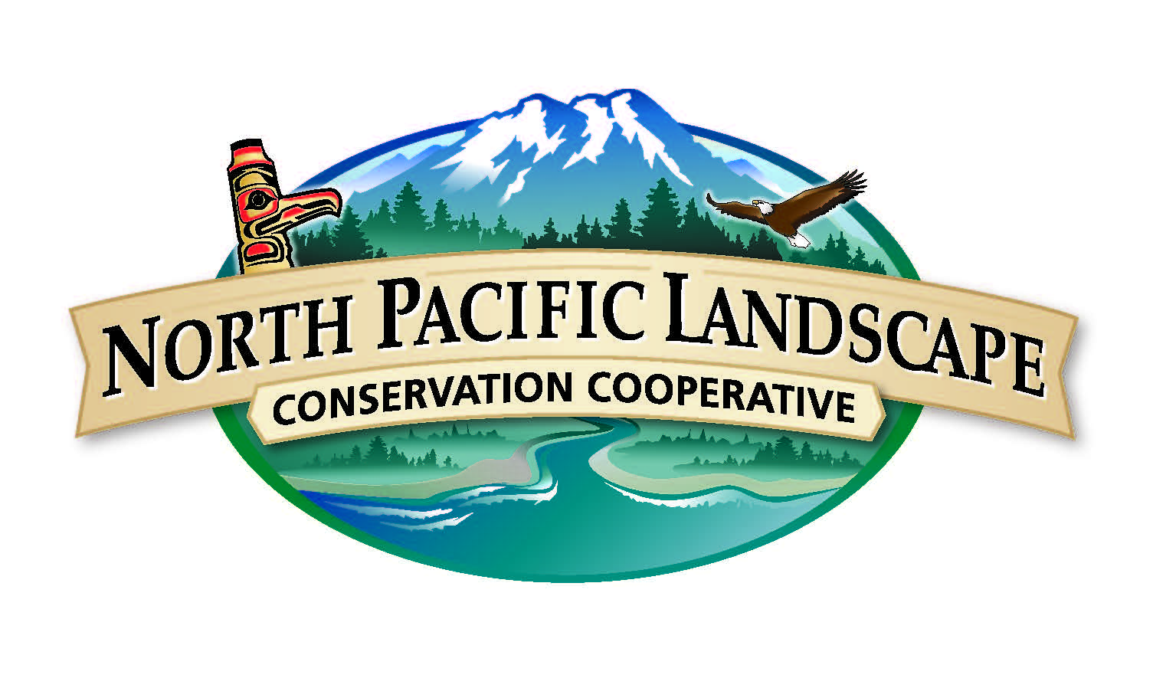
North Pacific Landscape Conservation Cooperative
Steering Committee Meeting
November 3, 2014 | 1:00 p.m. to 5:00 p.m. Alaska Time

Meeting Logistics

Monday, November 3rd
Hotel Captain Cook
Quadrant Room
939 West 5th Avenue
Anchorage, AK, USA 99501

Conference Call Information
Conference Call Number: 866-628-1318
Conference Call Code: 6959549
Access Adobe Connect: http://enviroissues.adobeconnect.com/nplccmtg/
MeetingSphere: https://us01.meetingsphere.com/99286380/nplcc-11-3-14

Meeting Agenda

Meeting Objectives

- Learn about LCC Network activities, NPLCC accomplishments in 2014, and anticipated activities in 2015.
- Articulate a 5-year outlook for the NPLCC and develop a 2015 Work Plan.
- Identify Steering Committee meeting dates and locations for 2015.

Time | Topic | Outcome | Lead
1:00 p.m.  (Alaska)  2:00 p.m. (Pacific) | Welcome and Introductions | - Review agenda and meeting objectives  - Introductions  - Approve summary from July 9-10 meeting (link) | Rory Annett & Lyman Thorsteinson, NPLCC Co-Chairs  Penny Mabie, Facilitator
1:20 p.m. (Alaska)  2:20 p.m. (Pacific) | LCC Network Activities and NPLCC Accomplishments | - Learn about LCC Network Strategy and major initiatives  - Highlight NPLCC accomplishments in 2014 and anticipated activities in 2015  - Tribes/First Nations Committee  - S/TEK Subcommittee  - Communications Subcommittee  - Partnership Engagement Strategy | John Mankowski, NPLCC Coordinator  Terry Williams, Tribes/First Nations Committee  Frank Shipley, Science and Traditional Ecological Knowledge Subcommittee Chair  Mary Mahaffy, NPLCC Science Coordinator  Mike Tranel, Communications and Outreach (COR) Subcommittee Chair  Meghan Kearney, NPLCC Communication Specialist
Resources
- LCC Network Strategic Plan (link)
- COR Strategic Plan (link) and 2014 Implementation Plan (link)
2:15 p.m.  (Alaska)  3:15 p.m. (Pacific) | Group Activity  2015 Strategic Planning | - Articulate 5-year outlook consistent with NPLCC mission and goals  - Identify opportunities and barriers to achieving 5-year outlook  - Develop 2015 Work Plan  - Identify major deliverables and task leads  - Identify dates and locations for Steering Committee meetings | Steering Committee, facilitated by Penny Mabie
4:30 p.m.  (Alaska)  5:30 p.m. (Pacific) | Meeting Wrap Up | - Review progress and action items | Penny Mabie
5:00 p.m. (Alaska)  6:00 p.m. (Pacific) | Adjourn

Contact Information
Penny Mabie, facilitator  pmabie@enviroissues.com | John Mankowski, North Pacific LCC Coordinator  John_Mankowski@fws.gov

