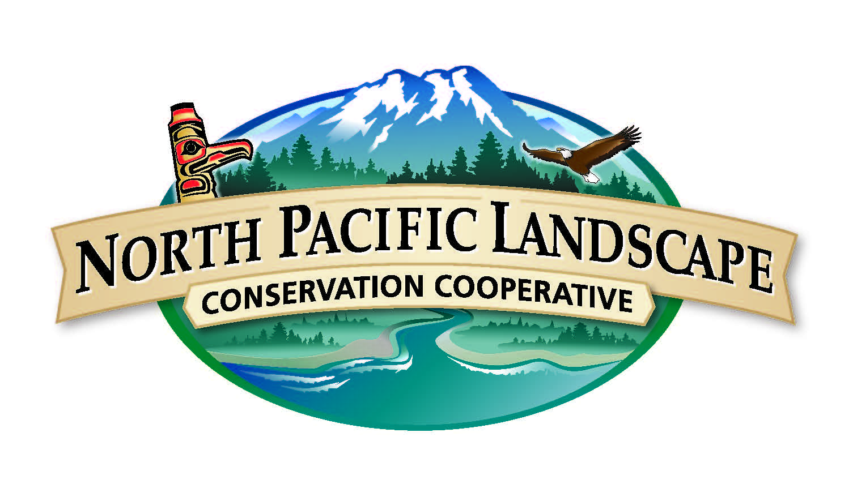
North Pacific Landscape Conservation Cooperative
Communications & Outreach Subcommittee Meeting
Sept 15, 2015 | 2 p.m. to 3 p.m. PST / 1 p.m. to 2 p.m. Alaska

Conference Call Information
Call Number: 866-628-1318
Passcode: 6959549

WebEx Information
Join the meeting: http://www.mymeetings.com/nc/join.php?i=449949835&p=NPLCC&t=c
Meeting Number: 449949835
Meeting Passcode: NPLCC

Meeting Objectives
- Review Performance Measures & Outreach Highlights
- Discuss Network and NPLCC Future COR products and goals

Agenda
Time | Topic | Purpose | Lead
2 p.m. PST/1pm AK | Welcome and Introductions | - Meeting purpose and outcomes  - Agenda overview  - Introductions | Mike Tranel, COR Chair  John Mankowski, NPLCC Coordinator
2:05 p.m. | LCC Network Updates | - Introduction from Laura  - Updates on Network Comms | Laura MacLean, Network Comms Manager
2:15 p.m. | Performance Measures May-August | - Share new performance measures report/Implementation Plan Review  - Updates on Beaver Guidebook & Climate Magazine Stats | Meghan Kearney
2:25 p.m. | Outreach Highlights | - GLACIER participation  - TNC Webinar | Meghan Kearney
2:30 p.m. | Upcoming products/goals | - “Showing our value” focus  - NW Climate Mag 2016  - Resources Library/Student Project  - Discuss end of year performance report/highlights | John Mankowski; Meghan Kearney  Group Discussion
2:45 p.m. | Round Robin | - Updates from COR Committee Members | All
2:55 p.m. | Next Steps | - Identify next COR meeting day and topics  - Follow-up & action items | Meghan Kearney
3:00 p.m. | Adjourn

Contact Information

Meghan Kearney, Communication Specialist
Meghan_kearney@fws.gov
360-753-7766

John Mankowski, NPLCC Coordinator
john_mankowski@fws.gov
360-534-9330
Website www.northpacificlcc.org

