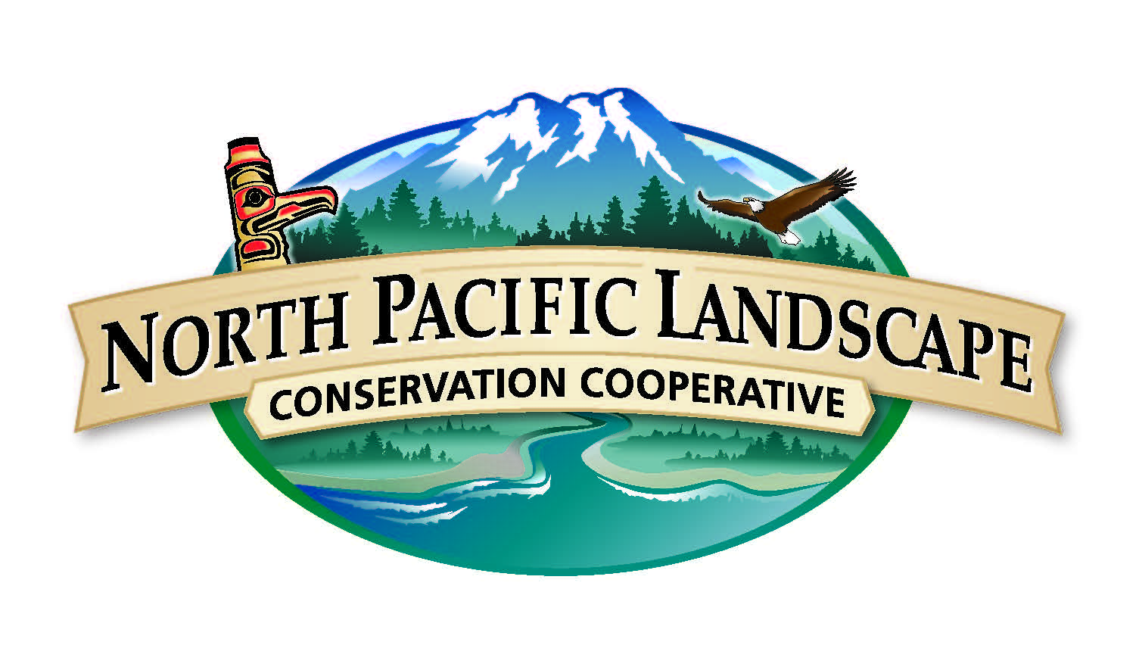
COR Subcommittee Call Notes – May 18th, 2015

Participants: Mike Tranel, Meghan Kearney, John Mankowski, David Redhorse, Wayne Owen, James Partain, Sue Rodman, Lynn Helbrecht, Pete Broussard
Introductions:
- Mike provided an overview of the agenda
- John introduced our new subcommittee member, Pete Broussard - Engineering Supervisor for BLM in Coos Bay, Oregon
Implementation Plan & Analytics Report:
- Meghan reviewed the 2015 Implementation plan and shared the January-April, 2015 Analytics Report. We are hitting and in most cases surpassing most of our target measures. Some areas that need work are Facebook audience growth and engagement. Twitter is making high impressions, but we will aim to increase engagement by the next report.
Steering Committee Updates:
- John provided updates from the May in-person Steering Committee Meeting
  - Steering Committee welcomed new co-chair, Barry Smith of the Canadian Wildlife Service; approved 10 recommendations from the Tribes/First Nations Committee; and began shaping the NPLCC 5 year strategic plan, which will help guide COR priorities as we move forward.
- Meghan shared that we received great feedback from the Steering Committee on our COR Analytics report and updates, and consensus among Committee that communications is still a key priority.
Other COR updates:
- We looked at a preview of the Northwest Climate Magazine – a collaborative product from the NPLCC, Northwest Climate Science Center and Climate Impacts Research Consortium (Officially released, read & download here)
- Reviewed the idea of creating LCC newsletters or “updates” for different organizations – for example, the NPLCC, GNLCC, PICCC & GBLCC are developing a newsletter for U.S. Fish & Wildlife Pacific Region to highlight what LCCs are doing relevant to USFWS.
- Reviewed upcoming NPLCC COR project – partner profiles. We will begin to develop a “partner database” that will have important information for all of our partners and potential partners with basic information & needs. This will help us better understand how to provide targetd value to partners.
  - We can also develop targeted COR products such as general communication, fact sheets and other targeted messages based off these profiles

Round Robin
- Wayne shared information on the Native American Fish & Wildlife Youth Engagement & Climate Change conference. He also shared that in rural Alaska, the public is requesting climate change issues as a needs for changes in fishing/hunting regulations for the first time ever.
- James shared a story of about Fairbanks FWS asking for advanced warning on freezing rain because it would help better determine regulations around Caribou hunting – as the freezing rain causes greater die off. Discussed this as a new way to look at climate change playing a role in our shared goals.
- Sue shared the Alaska Dept of Fish & Game’s monthly newsletter – story/interview based. View here.
- Mike is going to help look into where the NPLCC is linked around the web (i.e. on partner sites/climate pages)
Next Steps
- Our next call will be sometime in August/September and we will send a Doodle Poll closer to that time

