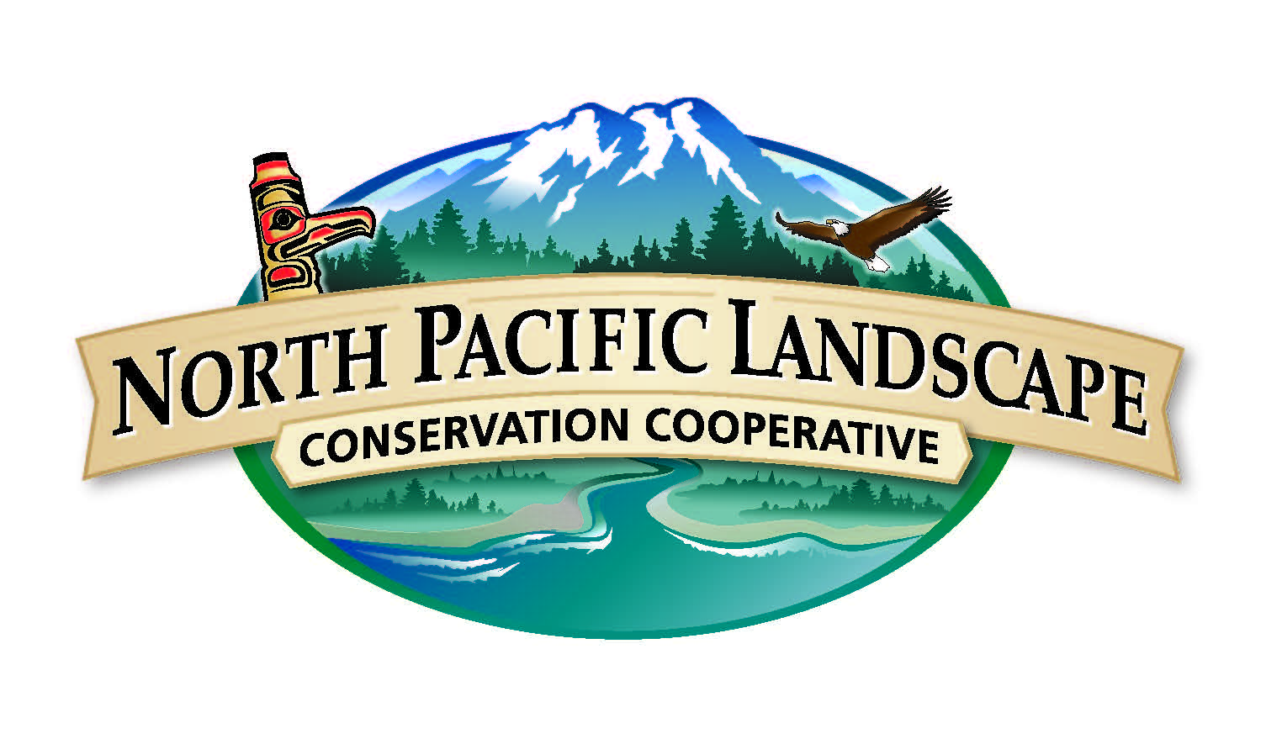
North Pacific Landscape Conservation Cooperative
Communications & Outreach Subcommittee Meeting
May 18, 2015 | 2 p.m. to 4 p.m. PST / 1 p.m. to 3 p.m. Alaska

Conference Call Information
Call Number: 866-628-1318
Passcode: 6959549

WebEx Information
Join the meeting: http://www.mymeetings.com/nc/join.php?i=449949835&p=NPLCC&t=c
Meeting Number: 449949835
Meeting Passcode: NPLCC

Meeting Objectives
- Review Progress on 2015 Implementation Plan & make adjustments
- Discuss new COR products & ideas and provide feedback

Draft Agenda (2-hour meeting)
Time | Topic | Purpose | Lead
2 p.m. PST | Welcome and Introductions | - Meeting purpose and outcomes  - Agenda overview  - Introductions  - Welcoming our new member | Mike Tranel, COR Chair  John Mankowski, NPLCC Coordinator
2:10 p.m. | Review 2015 Implementation Plan Progress | - Review Implementation Plan  - View January-April Analytics Report, adjust where needed | Meghan Kearney, NPLCC Communications Specialist
2:40 p.m. | Steering Committee COR Updates | - Discuss COR topics from Steering Committee meeting | John Mankowski & Meghan Kearney
3:00 p.m. | Other COR Updates | - Twitter recap from Adaptation Forum  - Preview NW Climate Magazine & provide feedback  - New products and ideas | Meghan Kearney
3:35 p.m. | Round Robin | - Share your and/or your agency’s communications work, including information on people, projects, and other activities | All
3:50 p.m. | Next Steps | - Identify next COR meeting day and topics  - Follow-up & action items | Meghan Kearney
4:00 p.m. | Adjourn

Contact Information

Meghan Kearney, Communication Specialist
Meghan_kearney@fws.gov
360-753-7766

John Mankowski, NPLCC Coordinator
john_mankowski@fws.gov
360-534-9330
Website www.northpacificlcc.org

