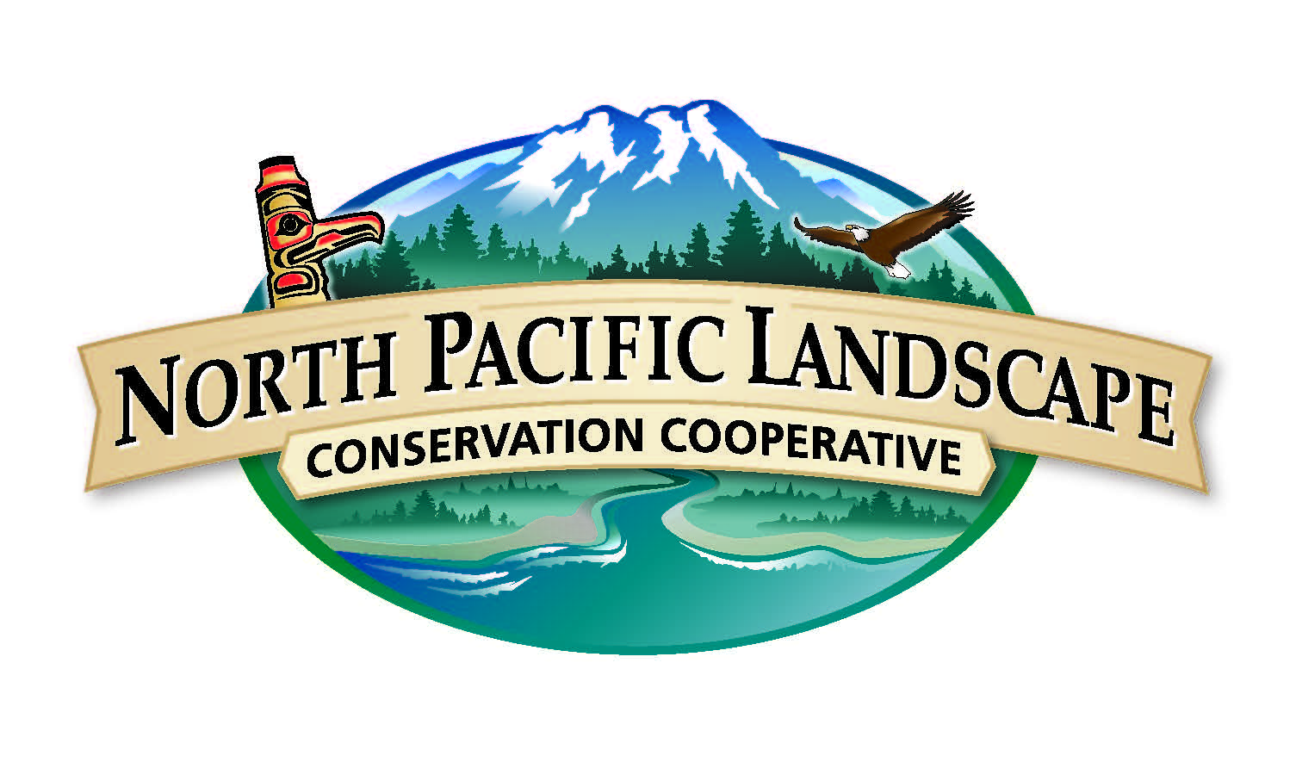
North Pacific Landscape Conservation Cooperative
Communications & Outreach Subcommittee Meeting
December 10, 2014
2:00 p.m. to 4:00 p.m. PST / 1:00 p.m. to 3:00 p.m. Alaska

Conference Call Information
Call Number: 866-628-1318
Passcode: 695-9549

WebEx Information
Join the meeting: http://www.mymeetings.com/nc/join.php?i=449949835&p=NPLCC&t=c
Meeting Number: 449949835
Meeting Passcode: NPLCC

Meeting Objectives
- Approve the 10/16/14 meeting summary and provide ideas for the 2014 annual report.
- Develop COR’s 2015 work plan including performance measures and metrics.
- Ensure COR’s 2015 work plan is consistent with the NPLCC charter, COR Strategy, and Steering Committee guidance. Identify if new COR members are needed.
- Learn about new communications opportunities and hear updates from COR members.

Draft Agenda
Time | Topic | Purpose | Lead
2:00 p.m. PST | Welcome and Introductions | - Introductions  - Meeting purpose and outcomes  - Agenda overview | Mike Tranel, COR Chair  Tricia Tillmann, Facilitator
2:05 p.m. PST | COR Business | - Approve 10/16/14 meeting summary  - Hear about 11/3/14 Steering Committee meeting  - Provide ideas for the 2014 annual report | John Mankowski, NPLCC Coordinator  Mike Tranel  Tricia Tillmann
2:30 p.m. PST | 2015 Work Plan | - Discuss and revise draft 2015 work plan to:  - Identify work to continue  - Identify new tasks  - Develop performance measures and metrics  - Discuss potential new members who could assist with implementation  Handouts:  - NPLCC Charter (link)  - COR Strategy (link)  - Draft 2015 COR Work Plan  - Draft COR Roles/Responsibilities (link) | Meghan Kearney, NPLCC Communication Specialist  Tricia Tillmann
Notes:
- The draft work plan will be up on the WebEx. We will edit the plan during the call.
- The discussion is another opportunity to confirm the work COR has been doing and look ahead to the roles COR could fulfill as the needs and work of the NPLCC changes. For example, COR Priorities 5 and 6 have received less attention to-date and could be an added focus for 2015.
3:40 p.m. PST | Round Robin | - Share your and/or your agency’s communications work, including information people, projects, and other activities  - Describe how you are/have shared the NPLCC’s work  - Recommend events for NPLCC staff to attend, including role at the event | John Mankowski  Tricia Tillmann
Notes:
- Use Round Robin to learn about new and relevant people and activities, including:
  - Any new communications specialists?
  - Upcoming webinars, conferences, trainings, workshops, etc. of interest to you?
  - Content to share from your region, from AK/BC, etc?
  - How you are sharing NPLCC work
  - Recommend events for NPLCC staff to attend
3:55 p.m. PST | Next Steps | - Identify next COR meeting day and topics  - Follow-up & action items | Tricia Tillmann
4:00 p.m. PST | Adjourn

Contact Information

Meghan Kearney, NPLCC Communication Specialist  meghan_kearney@fws.gov  503-231-2391  Tricia Tillmann, Facilitator  ptillmann@enviroissues.com  206-269-5041 | John Mankowski, NPLCC Coordinator  john_mankowski@fws.gov  360-534-9330

Website www.northpacificlcc.org

