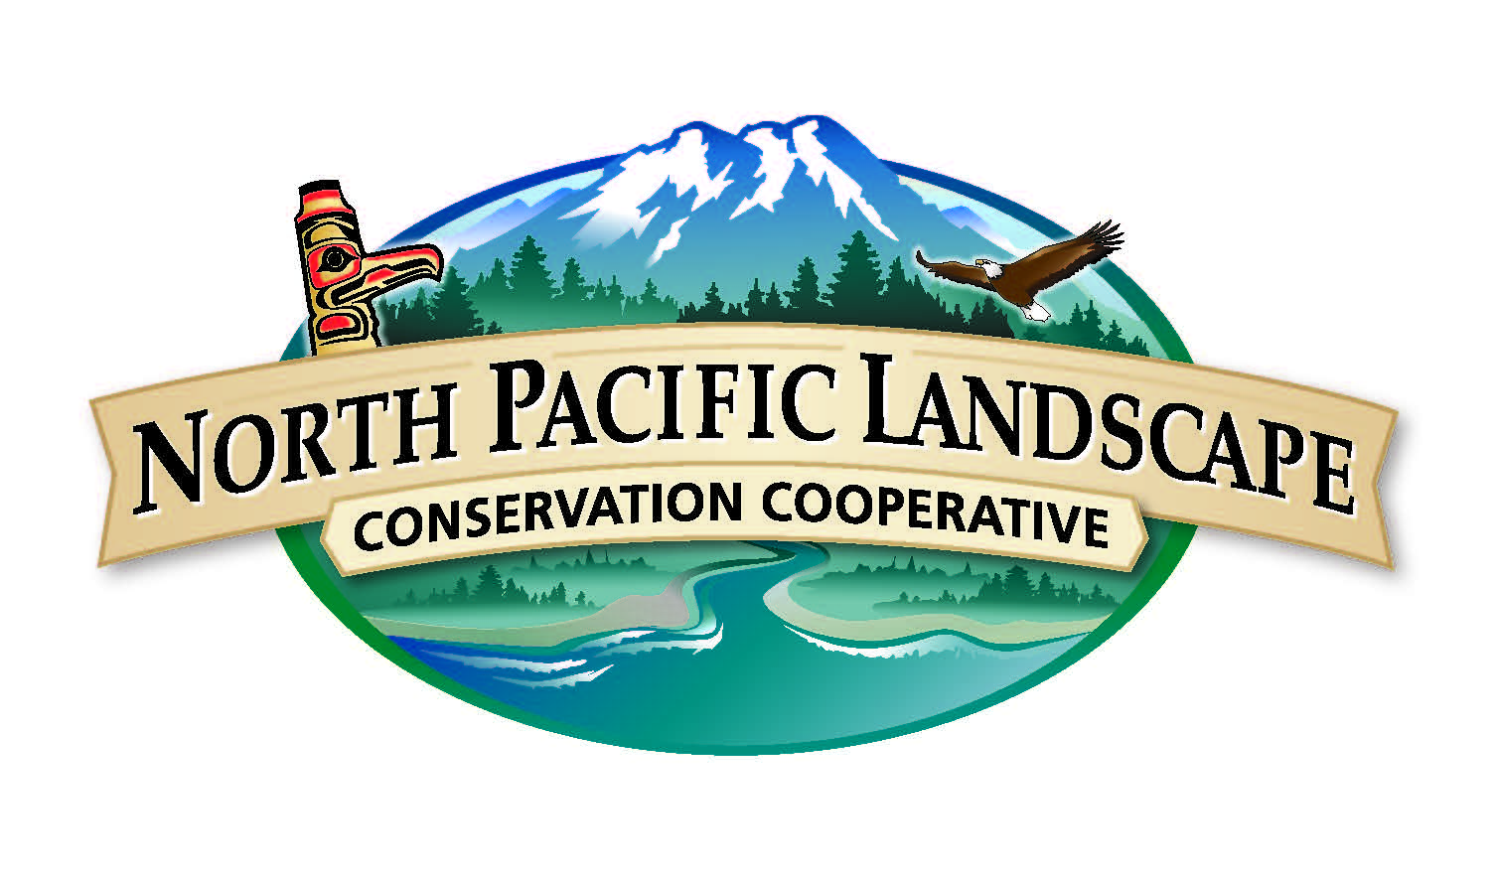
North Pacific Landscape Conservation Cooperative

Communications & Outreach Subcommittee Meeting

October 16, 2014

2:00 p.m. to 4:00 p.m. PST / 1:00 p.m. to 3:00 p.m. Alaska

Participants
Lynn Helbrecht Washington Department of Fish and Wildlife
Wayne Owen U.S. Forest Service
Chris Tunnoch British Columbia Ministry of Forests, Lands, and Natural Resource Operations

Others in attendance
John Mankowski North Pacific LCC, Coordinator
Mary Mahaffy North Pacific LCC, Science Coordinator
Meghan Kearney North Pacific LCC, Communication Specialist
Tricia Tillmann EnviroIssues, Facilitator

Table of Contents
Welcome and Introductions 2
National and NPLCC Communications Update 2
COR Subcommittee Next Steps 3
Round Robin 6
Next Steps 7
Appendix A. COR Roles and Responsibilities Discussion Document 8

Welcome and Introductions
Tricia Tillmann, EnviroIssues, welcomed everyone to the meeting and reviewed the agenda. The objectives for the meeting were:
- Learn about new communications opportunities and hear updates from Communications and Outreach Subcommittee (COR) members.
- Confirm COR roles and responsibilities based on COR strategy and implementation plans.
- Improve the relevance and impact of the Climate Science Digest.

National and NPLCC Communications Update
Meghan Kearney, North Pacific LCC (NPLCC), provided a national and NPLCC communications update:
- LCC Network
  - The final draft of the LCC Network Strategic Plan includes a communications section and is scheduled for release on October 20. NPLCC staff have developed a communications strategy for the release of the plan.
  - Six LCC conservation and action profiles were combined to create a briefing paper. The paper will be taken to congressional briefings and meetings.
- NPLCC website, newsletters, and science-management webinars
  - The NPLCC website has been updated:
    - Each News story has a dedicated page and uses tags to link to similar topics.
    - The calendar can display multiple events in a single day.
    - Each project shown in Projects/Resources has its own dedicated page.
  - The NPLCC is collaborating on two additional newsletters:
    - The NPLCC will now update the Climate Science Digest with current events, while the Northwest Climate Science Center (NW CSC) will provide science updates. The Digest and its companion NPLCC newsletter, the North Pacific Tidings, will be used primarily to spotlight partners.
    - The NPLCC is working with the Climate Impacts Research Consortium to create an annual Northwest Climate Science Newsletter.
  - The science-management webinars are ongoing and successful.
- NPLCC publications and conferences
  - NPLCC projects were featured in several reports. Two projects were included as implementation examples in the National Fish, Wildlife, and Plants Climate Adaptation Strategy progress report from September 2014 (link).
  - The first meeting of the Tribes / First Nations Committee, held September 4, 2014 in Portland, Oregon, went well. Participants will receive the draft meeting summary for review soon.
  - Five NPLCC-funded projects were featured at the Pacific Northwest Climate Science Conference (link), held September 9-10, 2014 at the University of Washington.
  - The NPLCC is preparing a poster showcasing tribal and traditional knowledge projects for the National Workshop on Large Landscape Conservation (link) taking place October 23-24, 2014 in Washington D.C.
- NPLCC project tracking system
  - Many projects are being added to the project tracking system. The NPLCC’s conservation and action profiles will be stored in this system.
- Other NPLCC business
  - Website and social media analytics continue to be tracked and will inform development of the COR 2015 Implementation Plan. A new analytics report may be available for the next COR meeting.
  - The Science and Traditional Ecological Knowledge Subcommittee (S-TEK) plans to assign one S-TEK member to each NPLCC-funded project. The person will serve as a liaison between COR and Principal Investigators.

Subcommittee Discussion
John Mankowski, NPLCC, asked the committee for feedback on the items Meghan covered.

All participants congratulated the NPLCC on their communications efforts. Lynn suggested sending a status update before COR meetings that includes information on the performance of communications efforts (organized by priority) and suggested changes to improve performance. Meghan agreed to send status updates in advance of future meetings.

John Mankowski added that metrics of the NPLCC’s work need to be more clearly defined and used to adjust the NPLCC’s actions as well as report on the NPLCC’s performance. He noted the potential analytics already defined by the subcommittee are qualitative, not quantitative.

Chris Tunnoch suggested the timing was right to begin tracking performance because some measures have been identified and some work has been done. Mary Mahaffy, NPLCC, suggested adding a column to the existing evaluation spreadsheet to identify measures and another to track their progress. Participants agreed. Chris Tunnoch suggested the subcommittee would need a way to phase out approaches that are no longer working. Mary noted the current COR Implementation Plan covers some aspects of a phase-out process.

Committee members decided to use their next meeting to develop a 2015 Implementation Plan, including quantitative performance measures.

COR Subcommittee Next Steps
Tricia Tillmann introduced the agenda topic, noting it would begin with a discussion of proposed roles and responsibilities for COR, followed by discussion about recruiting new COR members and a review of the most recent Climate Science Digest.

Subcommittee Discussion: Proposed COR Roles and Responsibilities
Tricia Tillmann reviewed the handout of proposed COR Roles and Responsibilities (Appendix A). She noted the handout is a discussion document and asked the subcommittee for feedback on the proposed roles and responsibilities.

Lynn Helbrecht suggested COR’s role is to develop the COR strategy and associated implementation plans, and ensure the plans are being implemented effectively and appropriately. Chris Tunnoch noted COR is already fulfilling those roles. Mary Mahaffy suggested using the handout as an input when developing the 2015 COR Implementation Plan and comparing the proposed roles and responsibilities with the COR Strategy to identify roles and responsibilities going forward. Participants agreed.

John Mankowski asked for feedback on the specific responsibilities outlined.

Chris Tunnoch asked for clarification on how COR members will update Meghan Kearney when new communications specialists are hired. Lynn Helbrecht suggested sharing a list of current communications specialists.

Lynn Helbrecht shared that although the third proposed role – “COR members help ensure ongoing and completed projects are well-communicated” – is a new role, she supports the idea and the associated responsibilities. She suggested COR develop communications expectations to include in Requests for Proposals (RFPs).

Mary Mahaffy noted she invited COR to serve on the RFP work team to better incorporate communications expectations in proposals. She offered to send information about the next S-TEK meeting, which is scheduled for late January or early February 2015. Participants suggested more attention was needed on actionable science.

Participants decided to work on how to support the funding and implementation of actionable science, including how to evaluate the communication of actionable science.

Subcommittee Discussion: New COR Members
John Mankowski asked if committee members had suggestions for new members, in light of the proposed roles and responsibilities and the committee’s upcoming work.

Chris Tunnoch requested ideas and support to improve outreach efforts with Tribes and First Nations. John Mankowski replied that David Redhorse, Bureau of Indian Affairs, is currently a COR member and Lindsay Wood, B.C. Ministry of Aboriginal Relations and Reconciliation, may be able to assist with outreach to First Nations. Mary Mahaffy suggested Kathy Lynn of the Pacific Northwest Tribal Climate Change Network and Sue Wotkyns of the Institute for Tribal Environmental Professionals may be resources. Lynn Helbrecht added that the choice of committee member depends on COR’s goals for cultural resource communications.

John Mankowski noted the results of the NPLCC-funded traditional ecological knowledge projects are becoming available and COR’s Priority 6 – “Communicate how climate change impacts cultural resources” – has received less attention to date. He suggested COR make a formal request to Kathy Lynn, Sue Wotkyns, Lindsay Wood, the Northwest Indian Fisheries Commission, the Affiliated Tribes of Northwest Indians, and the NPLCC’s Tribes / First Nations Committee for ideas on how to communicate the results of the projects. Participants agreed.

Wayne Owen suggested sharing results via social media and by attending relevant conferences such as the Alaska Forum on the Environment and those hosted by the Native American Fish and Wildlife Society.

Subcommittee Discussion: Review of Most Recent Climate Science Digest
John Mankowski suggested one responsibility for COR may be to ensure the Climate Science Digest and North Pacific Tidings are relevant and useful communications tools. He noted the Climate Science Digest is well-received by those on the list serve. Readers email regularly with positive feedback, and very few unsubscribe from the list. He asked if the Climate Science Digest was meeting COR members’ expectations and noted a reader survey would be distributed to assess the Climate Science Digest.

Lynn Helbrecht responded she is looking for very brief summaries relevant to Washington Department of Fish and Wildlife staff. She likes the learning opportunities included in the Digest. She suggested the role of the NPLCC and NW CSC is to ensure the Digest includes the right and complete information, with a two- to three-line summary and links readers can access.

Chris Tunnoch shared that the Digest is meeting her expectations. She noted the Digest and North Pacific Tidings are similar enough that they may be seen as one newsletter by some readers. She suggested distinguishing the two newsletters by titling them distinctly or publishing them farther apart from each other. She also suggested the NPLCC consider how to combine the two newsletters into a single newsletter.

Mary Mahaffy noted some readers only view the first three items in the Digest and it is difficult to communicate all the relevant information when the first three items receive most of the views.

Lynn Helbrecht suggested making it easy to scroll through the newsletter and noted the pictures are not needed. Wayne Owen added he does not read the Digest but does skim the North Pacific Tidings. John Mankowski noted many readers click on pictures and forward the newsletter to their networks, resulting in about three to five additional subscriptions each time a newsletter is distributed.

Chris Tunnoch suggested adding a “News” tab to the menu navigation on the NPLCC website and including a link to Climate Science News.

Lynn Helbrecht supported the suggestion and added that the Digest and North Pacific Tidings could be linked from the same location.

Round Robin
Tricia Tillmann invited COR members to provide updates on their communications work and describe how they are sharing the NPLCC’s work. The table below summarizes the discussion.

COR Member | Update
Wayne Owen  U.S. Forest Service | - The Native American Fish and Wildlife Society will have a conference in late spring 2015 in Juneau, Alaska. Up to 300 people are expected. There is a good fit for NPLCC projects. Wayne will send more information as it is available.  - Deborah Hart, Southeast Alaska Fish Habitat Partnership Coordinator (link), plans to engage more in communications work.  - The U.S. Forest Service, Alaska region, plans to collaborate with the NPLCC to share recent climate change work.  - The U.S. Forest Service, Alaska region, is hiring a full-time large-scale partnership development staff person to work out of the regional public affairs office.  - Their role will be to build relationships with corporate donors, foundations, and other organizations with an interest in the Forest Service’s work. Wayne plans to introduce them to the NPLCC once they are hired.
Chris Tunnoch  B.C. Ministry of Forests, Lands, and Natural Resource Operations | - The Ministry’s intranet is being redesigned, with the goal to release the new system by late January 2015. Chris is developing a page on LCCs to:  - Demonstrate the successes associated with being involved with LCCs, including a space for the Minister to highlight the benefits of partnership with the three LCCs in B.C.  - Provide information on project funding and how to lend support
Lynn Helbrecht  Washington Department of Fish and Wildlife | - The NPLCC-funded culvert project is going very well. It is an opportunity to talk about the NPLCC as a funder, and the project team has begun outreach.  - Cynthia Wilkerson, Great Northern LCC Steering Committee member, works on large landscape conservation. Her and her colleagues are discussing how to work on LCCs more productively and communicate about them more effectively.  - Lynn is working with Dan Siemann, Washington Department of Natural Resources Executive Policy Advisor for Climate and Energy, to establish an inter-agency climate group.  - The group has met once. At their next meeting (estimated December 2014), they would like to hear from the NPLCC about their projects and services.  - State agency staff from Washington who work on climate adaptation had lunch together at the Pacific Northwest Climate Science Conference. They are trying to establish a loose organization of federal, state and local staff who work on climate change.

Next Steps
Tricia Tillmann reviewed the action items from the meeting:
- NPLCC staff will discuss communications ideas and new COR members with the Tribes / First Nations Committee.
- NPLCC staff will send information on the next S-TEK meeting.
- Mike Tranel and NPLCC staff will review COR’s status and 2014 accomplishments at the November 3rd, 2014 Steering Committee meeting in Anchorage, Alaska.
- EnviroIssues will schedule the next meeting in early December 2014. The agenda will include developing a 2015 Implementation Plan and associated performance measures.

Tricia Tillmann thanked everyone for attending and adjourned the meeting.

Appendix A. COR Roles and Responsibilities Discussion Document
North Pacific Landscape Conservation Cooperative
Communications & Outreach Subcommittee
Roles and Responsibilities | Discussion Draft

Background: NPLCC staff and the COR chair reviewed the priorities in the COR Strategy and Implementation Plan to identify possible roles and responsibilities for committee members going forward. The proposed roles and responsibilities align with COR priorities. This document summarizes the ideas NPLCC staff and the COR chair generated and is intended as a starting point for committee discussion.
Role | Responsibilities | Applicable Priorities
COR members are liaisons and advisers for NPLCC communications. | - Suggest ways to improve the Tidings and Climate Science Digest.  - Suggest NPLCC and partner projects for webinars.  - Supplemental task: Share NPLCC updates (webpage, Tidings, Climate Science Digest) with professional networks and share organizational communications needs with NPLCC staff. | 1-3: Continue with website, newsletters, and science-management webinars
COR members provide strategic direction to help ensure the NPLCC stays on the cutting edge of communications. They recognize both replication of effort across LCCs and a unique role for the NPLCC are needed. | - Notify Meghan Kearney when new communications specialists are hired.  - Provide advice and brainstorm ways to highlight the variety of work and diversity of partners in the NPLCC region.  - Recommend events (e.g., conferences) for NPLCC staff to attend, including advice on how to participate (present, organize, etc.).  - Think about the NPLCC in the long-term – how will the NPLCC stay relevant and engage successfully with members and partners over time? | 4. Connect with similar regional efforts: LCC network, CSCs, RISA, Hubs, etc.  8. Highlight variety of work and diversity of partners
COR members help ensure ongoing and completed projects are well-communicated. | - Review projects that will be completed in the next quarter and provide advice on how to communicate project results effectively. S-TEK will provide communications ideas for COR to consider (e.g., we’re thinking about a webinar).  - Feature Tribal projects – how would COR recommend doing so?  - Use project tracking system as a tool  - Generate a list of good communications practices and deliverables for use by S-TEK, proposal reviewers, and principal investigators.  - Review the communications portions of full proposals submitted for NPLCC funding. | 5. Communicate the results of NPLCC-funded projects
COR members provide advice and brainstorm creative ways to communicate how climate change impacts cultural resources. | - Collaborate with Tribes and First Nations representatives on Steering Committee  - Recommend ideas for NPLCC staff to follow up on – case studies, organizations to contact (history, archaeology), funding for communications, etc. | 6. Communicate how climate change impacts cultural resources

